**Blood bank management**

Contents

**What this project will do** 3

**Out of scope items** 4

**Project team members** 5

**High level design** 6

**Data Model** 8

**Class Diagram** 9

**User stories** 9

**Database objects** 12

# **What this project will do**

This project aims at the following.

Expose a set of REST API services which will do the following:

1. POST Specimen API which can be used to record collection of blood units
2. GET Specimen API which can be used to list for blood units availability.
3. POST Procedure API to record blood transfusion.
4. GET Procedure API to return list of transfusion done.

# **Out of scope items**

1. Patient data will not be part of this scope.
2. Concurrency not part of scope.

# **Project team members**

* Bellcy Vinitha Samuelraj
* PADMA PRIYA E
* Sreeram Arivumuthu
* Sangeetha M
* Lakshminarayanan A.S

# **High level design**

|  |
| --- |
| Use case diagram |
|  |

|  |
| --- |
| Sequence diagram |
|  |

# **Data Model**

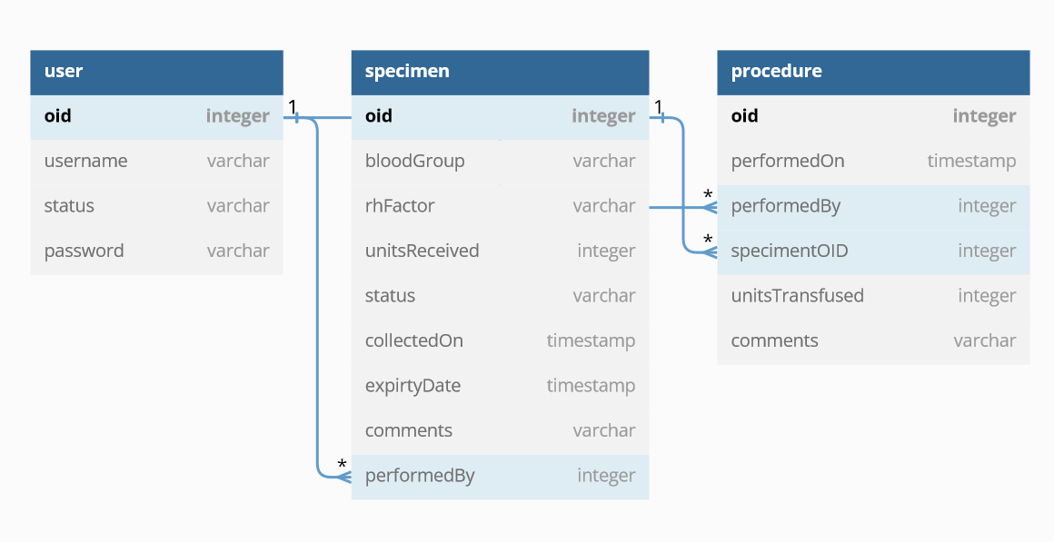

# **Class Diagram**

# **User stories**

| S.No | Description | Developer |
| --- | --- | --- |
| 1 | "POST Specimen | Sreeram |
| Summary: 1) Create record for every blood donation |
| 2) capture blood group, units donated, donatedOn, expiry date, rhfactor,Comments |
|  |
|  |
|  |
|  |
|  |
| 2 | PUT Specimen | Sreeram |
| Summary: 1) Record changes in donation |
|  |
|  |
|  |
|  |
|  |
|  |
|  |
|  |
| 3 | Get Specimen List | Lakshminarayanan |
| Summary: 1) get specimen list details like type, number of units available |
|  |
|  |
|  |
|  |
| 4 | Get Specimen by ID | Lakshminarayanan |
| Summary: 1) Search specimen based on OID |
|  |
|  |
| 5 | POST Procedure | Sangeetha |
| Summary: 1) Create record for every blood transfusion |
| 2) capture SepcimenOID, units transused performed date,Comments |
|  |
|  |
|  |
|  |
| 6 | PUT Procedure | Sangeetha |
| Summary: 1) Record changes in transfusion |
|  |
|  |
| 7 | Get Procedure List | Bellcy |
| Summary: get list of procedures done |
|  |
|  |
|  |
| 8 | Get Procedure by ID | Bellcy |
| Summary: return list of procedures |
|  |
|  |

# **Database objects**

Oracle Cloud Autonomous database is used for this project.

|  |  |  |  |
| --- | --- | --- | --- |
| **S.No** | **Object Name** | **Object type** | **Purpose** |
| 1 | User | Table | User table which can be used for login purpose in future |
| 2 | Specimen | Table | Used to record blood collections |
| 3 | Procedure | Table | Used to record blood transufions |
| 4 | Patient | Table | Patient details which will be used for Procedure table  This will be excel uploaded data |
|  |  |  |  |